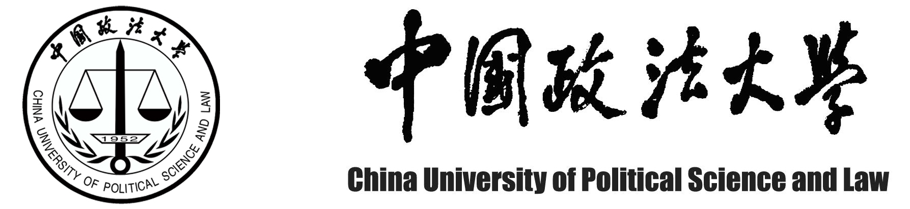

Certificate

______________________ is now the student (as Bachelor or Double-Bachelor) of Grade ____________in the __________________________College of China University of Political Science and Law . If nothing happens influencing his graduation and the degree conferment before graduation , he will be conferred the undergraduate diploma and the certificate for _____________________Bachelor Degree by the university In ___________(m),___________(y).

This certificate is thus to certify the above words.

Educational Affairs Office of CUPL
(seal)
__________/__________/_________/

地址：北京市昌平区府学路27号 电话：（010）58909114

